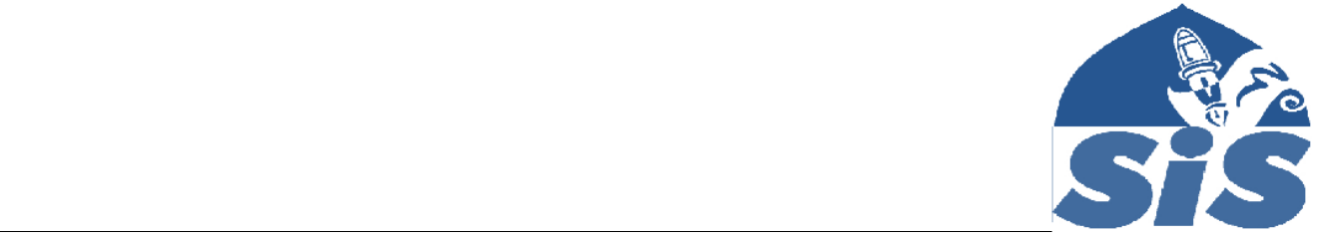
Privacy Notice
How we use workforce information

(staff, volunteers and governors)

The categories of school information that we process include:

- personal information (such as name, address, national insurance number, and other details required on the application form for employment at SIS)

- contract information (such as start date, hours worked, post, roles and remuneration information)
- work absence information (such as number of absences and reasons)

- qualifications (and, where relevant, subjects taught)

Why we collect and use workforce information

We use workforce data to:

- enable the development of a comprehensive picture of the workforce and how it is deployed

- inform the development of recruitment and retention policies

- enable individuals to be reimbursed

Under the General Data Protection Regulation (GDPR), the legal basis / bases we rely on for processing personal information for general purposes are:

- for the purposes of recruitment in accordance with the legal basis of (a) legal obligation, (b) contract, and (c) consent.

Storing workforce information

We hold data securely for the time that a staff member or volunteer is active in SIS. Once a staff member or volunteer leaves SIS the data is archived for five year and then physically destroyed.

Who we share workforce information with

SIS does not routinely share information with any other parties. The only exception is for the purposes of safeguarding and child protection issues. In which case, relevant data is shared with the relevant bodies.

Why we share school workforce information

We do not share information about our workforce members with anyone without consent unless the law and our policies allow us to do so.

Education & Fun in the Islamic Way

Requesting access to your personal data

Under data protection legislation, you have the right to request access to information about you that we hold. To make a request for your personal information, contact
farukhr@yahoo.com

You also have the right to:

- object to processing of personal data that is likely to cause, or is causing, damage or distress
- prevent processing for the purpose of direct marketing

- object to decisions being taken by automated means

- in certain circumstances, have inaccurate personal data rectified, blocked, erased or destroyed; and

- a right to seek redress, either through the ICO, or through the courts

If you have a concern about the way we are collecting or using your personal data, we ask that you raise your concern with us in the first instance. Alternatively, you can contact the Information Commissioner’s Office at https://ico.org.uk/concerns/

Contact

If you would like to discuss anything in this privacy notice, please contact:

farukhr@yahoo.com

2

