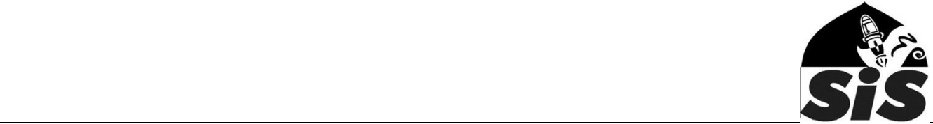
Data protection policy

Sevenoaks Islamic School (SIS) will comply with the terms of the 2018 Data Protection Act, and any subsequent relevant legislation, including the GDPR, to ensure personal data is treated in a manner that is fair and lawful.

Data Gathering

All personal data relating to staff, pupils or other people with whom we have contact, whether held on computer or in paper files, are covered by the Act. Only relevant personal data may be collected and the person from whom it is collected should be informed of the data’s intended use and any possible disclosures of the information that may be made.

Data Storage

Personal data will be stored in a secure and safe manner. Electronic data will be protected by standard password and firewall systems. Manual data will be stored where it not accessible to anyone who does not have a legitimate reason to view or process that data. Particular attention will be paid to the need for security of sensitive personal data.

Data Checking

The school will issue regular reminders to staff and parents to ensure that personal data held is up-to-date and accurate. Any errors discovered would be rectified and, if the incorrect information has been disclosed to a third party, any recipients informed of the corrected data.

Data Disclosures

Personal data will only be disclosed to organisations or individuals for whom consent has been given to receive the data, or organisations that have a legal right to receive the data without consent being given. When requests to disclose personal data are received by telephone it is the responsibility of the school to ensure the caller is entitled to receive the data and that they are who they say they are. It is advisable to call them back, preferably via a switchboard, to ensure the possibility of fraud is minimised.

If a personal request is made for personal data to be disclosed it is again the responsibility of the school to ensure the caller is entitled to receive the data and that they are who they say they are. If the person is not known personally, proof of identity should be requested.

Personal data will not be used in newsletters, websites or other media without the consent of the data subject. Routine consent issues will be incorporated into the school’s pupil data gathering sheets, to avoid the need for frequent, similar requests for consent being made by the school.

Personal data will only be disclosed to Police Officers if they are able to supply a written request or a WA170 form which notifies of a specific, legitimate need to have access to specific personal data. A record will be kept of any personal data disclosed so that the recipient can be informed if the data is later found to be inaccurate.

Subject Access Requests

If the school receives a written request from a data subject to see any or all personal data that the school holds about them this should be treated as a Subject Access Request and the school will respond within the 40 day deadline.

Education & Fun in the Islamic Way

