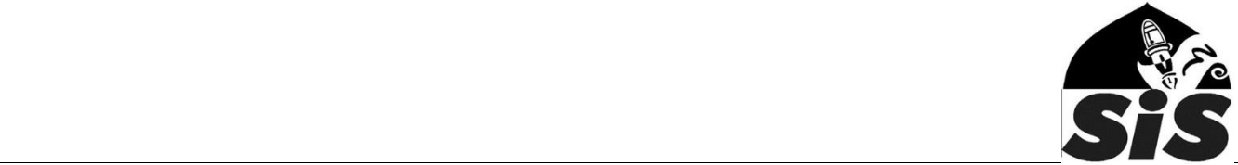
Behaviour & discipline policy

Sevenoaks Islamic School (SIS) aims to develop and foster Islamic behaviour in children by the means of discussion and appropriate examples. The school rejects any sort of punishments, which degrade the child, or hinder self-esteem. It has a strict behaviour policy, and works in partnership with the parents and guardians.

Guiding principles

At SIS we believe that a high standard of behaviour and discipline is crucial to achieving our aims and objectives. Discipline is a collective responsibility of all members of staff. All staff should take a positive and practical approach to discipline and use encouragement and high expectation to reinforce appropriate behaviour. We believe that children should be equipped with self-discipline and mutual respect. Staff should avoid any forms of punishments and overt rewards and always emphasise the rewards and exchanges from Allah in the life Hereafter.

Implementation of the policy

If a pupil fails to demonstrate the required standard of behaviour at any time, the teacher will made the pupil aware of what they need to do to improve. The teacher may take immediate actions, for example, move the pupil to a different seat, so that they can be successful. If this does not help then the teacher will discuss the issues with the pupil away from other pupils and agree on an action plan. The teacher will then inform other teachers so that they too can support and encourage the pupil to be successful.

If there is no improvement then the Branch In-Charge will be informed, who will then discuss the matter with the pupil and if necessary involve parents. We place great emphasis on consistency, fairness and working together with the child. Members of staff do not make threats unless they are both able and willing to carry it out.

Pupils must not be sent out of class under any circumstances. If the behaviour is too disruptive for the pupil to remain in class, please seek help from the adjacent classroom or seek support from the Branch In-Charge.

Use of rewards and sanctions

Pupils are provided with verbal praise and encouragement. Staff can also provide class treats such as additional playtime or doing a special activity to reward exceptional good behaviour. Kindly refrain from using stickers or giving class certificates as they have not long term educational benefits.

Pupils must be spoken to about unacceptable behaviour. In exceptional circumstances they may miss part of their playtime or spend part of the playtime to help staff members with various duties.

Dealing with unacceptable behaviour
If a pupil continues to misbehave despite receiving support from the teacher, the Branch In-Charge and the parents then they may be asked to stay at home for a week to reflect (fixed term exclusion). If this does not help then the Branch In-Charge will consult the Headteacher and the pupil may be taken off roll (permanent exclusion).

Parent will have a right to appeal against the decision to the Headteacher who will review the situation carefully.

Education & Fun in the Islamic Way

