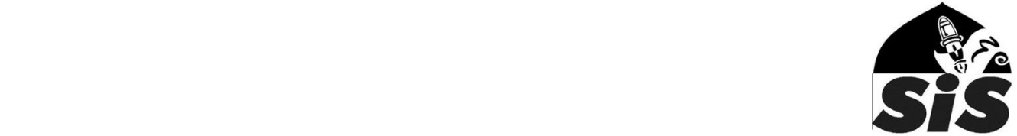
Anti-Bullying policy

Sevenoaks Islamic School (SIS) takes its responsibility to ensure that pupils in the school enjoy their rights seriously. All pupils have the right to be safe, be healthy, enjoy and achieve and make a positive contribution to school life and beyond. Any forms of bullying, racial or other type of harassment are not tolerated. The school is proactive in ensuring equality of opportunities for all.

What is bullying?

Bullying can be defined as a physical, psychological or verbal attack against an individual or group of individuals by a person or group of persons (possibly causing physical or psychological harm to the victim). It is usually conscious and wilful and commonly consists of repeated acts of aggression and/or manipulation. It can take a number of forms – both physical and non-physical, either in combination or in isolation. Any bullying, whether physical or non-physical, may result in lasting psychological damage to the individual.

Bullying generally falls into one or a combination of the following categories:

- Physical Bullying – Unprovoked assault on a person or group which can range from a ‘prod’ to grievous bodily harm.

- Psychological – Reduction of a person’s self esteem or confidence through threatening behaviour, taunting or teasing about race, gender, religion, sexual orientation, disability family circumstances, appearance, or any other feature of their lives which can be used to wound or humiliate them.

- Social – Ostracism/rejection by peer group.
- Verbal – The use of language in a derogatory or offensive manner, such as swearing, racist or sexist abuse, sexual innuendo, spreading rumours, etc.

- Cyber bullying – Using mobile phones or the internet to deliberately upset someone.

Objectives of this Policy

- Promote characteristics of a Muslim and support the bully and the victim in modifying their behaviour

- To ensure that everyone in the school community have an understanding of what bullying is and how the school will deal with incidences of bullying

- To develop a listening caring ethos at SIS where any form of bullying is not tolerated and dealt with in the appropriate manner

- To encourage discussion and not make premature assumptions and to foster a problem solving approach

Procedures

- Pupils should report bullying incidents to available staff or someone who they can trust. In cases of serious bullying, the incidents will be recorded by staff in the ‘Incident Book’ and investigated by the Branch In-Charge.

- Parents must report any bullying incidences using the attached form.
- In serious cases parents will be informed and will be asked to come in to a meeting to discuss the problem.

- The bullying behaviour or threats of bullying will be investigated and the bullying stopped quickly.

- An attempt will be made to help the bully (bullies) to change their behaviour through advice (nasiha).

Education & Fun in the Islamic Way

Outcomes

- The bully (bullies) will be asked to genuinely apologise and show remorse. Other consequences such as (a) an apology letter or (b) a written contract may be required.

- The school will aim to sort out differences and encourage the pupils to reconcile.

- In serious cases, parents will be informed in writing and suspension or even exclusion will be considered.

- After the incident / incidents have been investigated and dealt with, each case will be monitored the Branch In-Charge to ensure repeated bullying does not take place.

Prevention

SIS will use the weekly assemblies to rise and discuss issues that will help pupils develop essential Islamic characteristics including respect, generosity, compassion, brother/sisterhood and humility.

Education & Fun in the Islamic Way

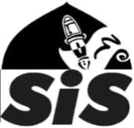
Report of a bullying/racist incident

PART ONE – to be completed by the person reporting the incident.

Full name/address of the

person reporting the incident

Date, time and place of the breach

Please provide a full description of the incident (specific details rather than general comments are required in order to deal with the reported incident)

Please use the other side or a separate sheet if required…
Signature: | Date:

PART TWO – To be completed by the person investigating the incident

Names of investigator(s) | Date the investigation took place
Main finding(s)

Actions taken and the support provided to the victim

Actions take and support provided to the perpetuator

Signature: Date:

Education & Fun in the Islamic Way

